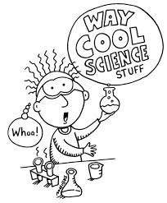
Science 14 – Course Outline 2014
Peace River High School - Mr. Pobuda & Mr.White
pobudaj@prsd.ab.ca / whitej@prsd.ab.ca

Welcome to Science 14. I hope it will be fun for you. This course is put together so that you can learn how different parts of the world you live in work. There are four units in this course. They are:

Unit 1: Investigating Properties of Matter (Nature of Science Emphasis)

Chapters 1 – 4 (Jan 31 – Mar 5)

Overview: The safe handling of chemicals, whether in the home or in the workplace, requires an understanding of the properties of pure substances and mixtures. Students will actively investigate the properties of a variety of samples of matter, including mixtures and solutions, elements, and compounds encountered in everyday life. The atom as the basic building block of matter is introduced. Students also investigate the classification of elements on the periodic table.

Key Concepts
• safe handling, storage and disposal of household chemicals  • Workplace Hazardous Materials Information System (WHMIS) and consumer product symbols  • solutions and solubility of household substances  • dilution and concentration  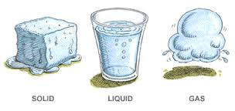 | • preparing solutions  • separating mixtures  • acids and bases  • the periodic table: metals, nonmetals and metalloids  • elements and compounds  • corrosion and rusting

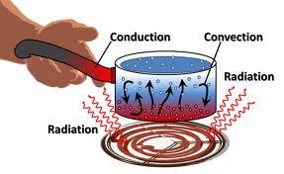
Unit B: Understanding Energy Transfer Technologies (Science and Technology Emphasis)

Chapters 5 – 7 (Mar 6 – April 4)

Overview: Energy can be transferred by means of heat and by use of force or distance multipliers called machines. The optimal design of such energy transfer technologies is based upon an understanding of energy transfer, heat and temperature, and force. Students will gain an understanding that the design of energy transfer technologies also takes into consideration the need for safety and for efficiency as a means of reducing reliance upon non-renewable energy resources.

Key Concepts
• cooling and heating systems based on radiation, convection, conduction  • particle model of matter, temperature, thermal energy and heat  • methods to reduce the loss of heat from buildings, our bodies and constructed devices  • specific heat capacity | • protection against thermal energy transfer  • simple machines as force or distance multipliers that transfer energy  • energy transfer (work), force and distance  • reducing reliance on nonrenewable energy sources  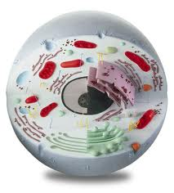
Unit C: Investigating Matter and Energy in Living Systems
(Science and Technology Emphasis)

Chapters 8 – 11 (April 7 – May 9)

Overview: Life processes require the exchange of matter between living systems and the external environment. Students will investigate life processes at the organism and system level, and extrapolate these processes to the cellular level. In closely studying the digestive and circulatory systems, students will understand that a healthy diet and lifestyle is crucial to their wellness.
Key Concepts
• structures and functions of, and the relationship between, the digestive and circulatory systems  • diets and human nutritional needs  • social influences on human dietary-induced disorders and circulatory diseases  • microscopy, structure and function of plant and animal cell parts, and the cell theory | • life functions common to living systems  • functions of cells in organs and organ systems  • photosynthesis and respiration  • capture, storage and use of energy by living organisms  • role of technology to monitor life functions

Unit D: Investigating Matter and Energy in the Environment (Social and Environmental Emphasis)

Chapters 12 – 15 (May 12 – June 6)

Overview: Energy from the Sun sustains living systems and maintains equilibrium in the biosphere. In the biosphere, matter is recycled along natural pathways. However, the increasing human population, human activity, and increasing human use of energy and reliance on manufactured materials are having an impact on the movement of matter and energy in the biosphere. This raises global concerns about sustainability.

Key Concepts
• role of living organisms in cycling matter  • flow of energy through the biosphere  • food chains, food webs and energy pyramids  • maintaining equilibrium in the biosphere  • recycling of human-generated wastes | • impact of modern agricultural technologies  • biotic and abiotic factors and ecosystems  • field study of ecosystems  • factors affecting population growth  • biodegradable materials
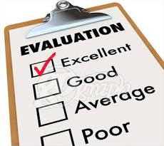
Evaluation:

Cumulative Grade:

70% - Units 1 -4

Each unit is worth 17.5% of your final grade. The marking scheme for each unit is as follows:

Classwork 30%
Labs/Assignments 40%
Chapter Tests 30%

Summative Grade:

30% - Exams and Project(s)

Midterm – 5%
Final Project – 5%
Final Exam – 20%

Classroom expectations:

I do expect you to be on time for class every day. You must have with you, your notebook, textbook, and pens and pencils. It is also a good Idea to have a ruler and calculator. Please do not touch any equipment that may be set up in the room. It could be dangerous.

Attendance is one of the most important factors for earning credits. It is expected that you come to class every day on time with the materials you need for class.

Work Habits - It is expected that students use their class time to the best of their abilities for the whole period every class. I expect everyone to listen to instructions. Please raise your hand and ask questions at any time during the class. Respectful behaviour is important to the class and will be given to everyone.

All notes, handouts, readings, assignment missed due to being absent are your responsibility. Please make arrangements with myself or a classmate to get missed materials. Should a quiz, lab or exam be missed due to an excused absence, you will be allowed to make it up on your own time.

Assignments are due by the end of class on or before the due date. If you miss a class when an assignment is due, then it will be due the next day you are back in class.

Mature and considerate behavior is expected in class. Safe and efficient laboratory practices are mandatory. Failure to comply with laboratory safety procedures and directions given by your teacher will result in removal from the class. Working cooperatively with others is essential.
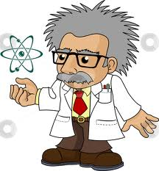

Questions, concerns, and or comments please contact us:

Mr. Pobuda – pobudaj@prsd.ab.ca 780 – 624-4221
Mr. White – whitej@prsd.ab.ca 780 – 624-4221

