Biology 30 Course Outline
Peace River High School 2014/2015

Instructor: Mrs. Lori Knoblauch (Rm 205) knoblalo@prsd.ab.ca

Welcome to Biology 30!

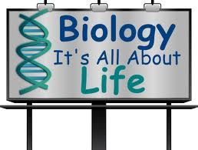

Introduction/Philosophy

The Alberta Learning Biology 20-30 Program of Studies identifies Biology 30 as an academic course that allows students to explore interests and prepare for further education and careers. Students graduating from Alberta schools require the scientific and related technological knowledge and skills that will enable them to understand and interpret their world. They also need to develop attitudes that will motivate them to use their knowledge and skills in a responsible manner.

To ensure relevance to students as well as to societal needs, the Biology 20-30 program presents science in a meaningful context—providing opportunities for students to explore the process of science, its applications and implications, and to examine related technological problems and issues. By doing so, students become aware of the role of science in responding to social and cultural change and in meeting needs for a sustainable environment, economy and society.

General Objectives (as per Alberta Program of Studies)

- To develop an understanding of the interconnecting ideas and principles that unifies the natural sciences.
- To enhance the student’s scientific world view
- To increase the student’s scientific awareness

Prerequisite

- Mark of 50% or higher in Biology 20

Tentative Schedule

Unit | Chapters | Dates | Topics
Nervous and Endocrine Systems | 11,12,13 | Sept 2 – Sept 29  (~25%) | - Homeostasis  - Nervous system  - Sensory systems (eye, ear)  - Endocrine system
Reproduction & Development | 14,15 | Sept 30 – Oct 22  (~20%) | - Anatomy and physiology of male and female reproductive systems  - The menstrual cycle  - Hormones regulating reproductive processes  - Pregnancy and gestational development  - The influence of environmental factors on embryonic and fetal development  - Reproductive technologies
Cell Division, Genetics and Molecular Biology | 16,17,18 | Oct 23 - Dec 10  (~40%) | - Cell division (mitosis and meiosis)  - Mendelian genetics  - Human and applied genetics (incl. pedigree and chromosome analysis)  - Molecular biology: basic structure of DNA, its role in protein synthesis and the impact of mutation
Population and Community Dynamics | 19,20 | Dec 11 – Jan 9  (~15%) | - Population structure and dynamics  - Natural selection and evolution  - Hardy-Weinberg Principle  - Interactions among members of communities  - Succession
- The Alberta Program of Studies is followed for all topics
- These dates are tentative and are subject to change.
- Time permitting, there will be days built into the schedule for midterm and final exam review.

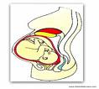

Extra Help (“there’s no such thing as a dumb question!”)

- Be sure to ask questions to clarify concepts!
- Success blocks may be scheduled for review/extra help/ study time
- Please do not hesitate to make an appointment with me to obtain any extra help you may need throughout the course.

Course Materials

- Textbook- Inquiry Into Biology (BRING TO EVERY CLASS)

- Binder with lined paper
- Pencils, pens, eraser, pencil sharpener and a ruler

- Pencil crayons or felt pens, highlighter

- Calculator (for Population Biology)


Evaluation

Evaluation in Each Unit
- Quizzes, Labs, Assignments 50%
- Chapter tests 50%

Course Grade
- Unit A 11%
- Unit B 9%
- Unit C 18%
- Unit D 7%
- Midterm Exam 5%
- Diploma Exam 50%


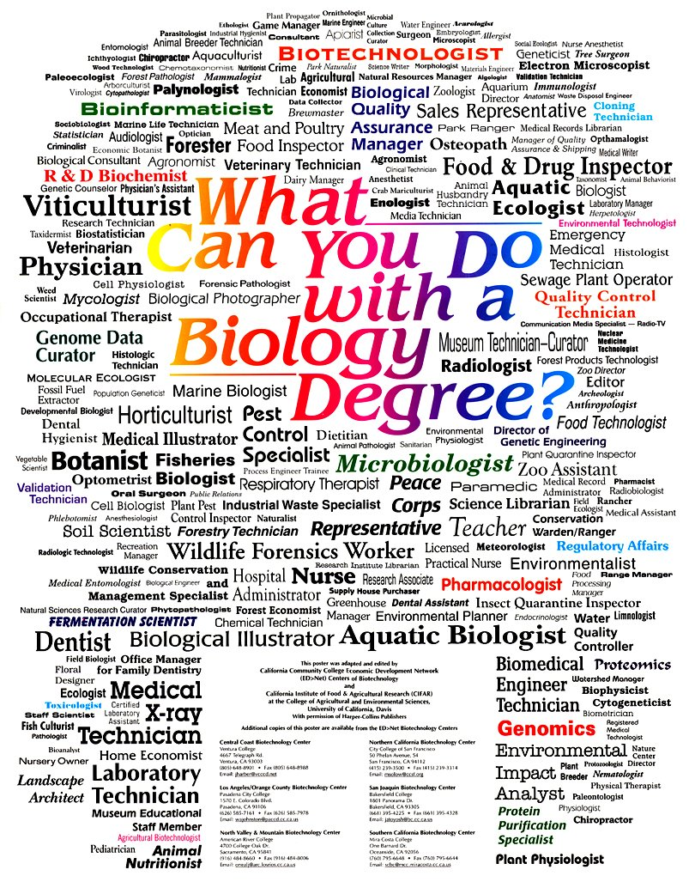

- Assignments will include textbook questions and investigations, worksheets, labs (including hands-on investigations such as dissections), and research projects.

- Quizzes will occur approximately once per chapter.

- Chapter tests will occur at the end of each chapter and will include a combination of multiple choice, numerical response, and written response questions.

- The mid-term exam will be held November 5th, 2014
- Marks are cumulative; they are a running tally of the students’ achievement throughout the semester.

- Evaluation will be objective based. Assessment will be determined by the course outcomes outlined in the program of studies.

- This is a 30-level course and as such 50% of your final overall course grade will come from a Government of Alberta diploma exam written on the scheduled examination day in January.

Teaching Methodology

Students will begin class each day with “bell work” that could include review of prior lessons or knowledge, a practice problem or sample test question, a reading assignment, etc. The purpose of bell work is to help keep students academically engaged from bell to bell.

Students will be taught through a variety of different instructional methods including: direct teaching, cooperative learning, independent learning, as well as small and large group discovery-based activities.

Lesson material will most often be delivered using the SmartBoard. Students will most often have fill in the blank note handouts to accompany these presentations. Use of educational videos, online tools, interactive gizmos and simulations will also be used to enhance lesson delivery.

General Expectations; Requirements for Success in Biology 30

- Attendance is one of the most important factors for academic success. It is expected that you come to class every day, on time, with the materials you require for class. Peace High attendance policy applies and will be strictly enforced.

- All notes, handouts, readings, and assignments missed due to absence are your responsibility. Please make arrangements with myself or with a classmate to obtain missed materials. Any missed handouts will be placed in the Bio 30 folder at the back of the room.

- Assignments are due at the beginning of class; on or before the due date. If you miss a class, due an excused absence, when an assignment is due, then it will be due the first day you are back in class.

- If you miss a test due to an excused absence, you may write the test in class on your first day back.

- Biology 30 is an in depth course that requires regular review and study of course material at home.

- Mature and considerate behaviour is expected in class. Respect for one another, for your teacher, and for the classroom is essential!

- Safe and efficient laboratory practices are mandatory. Failure to comply with laboratory safety procedures and directions given by your teacher will result in removal from the class and a grade of 0. Working cooperatively with others is essential.

- Music & iPods: Okay sometimes….
- During independent seat work, you are welcome to listen to music.
- You may NOT listen to music during instructional time or during any quiz, test, or exam.
- This is a privilege and can be easily removed.

- You are here to do the best you can!
Whether you think you can or think you cannot, you are right!

Home Logic

Students and parents can view attendance and marks at any time by logging into Home Logic, as found on the Peace River High School website. Attendance is taken daily, and marks will be entered as tasks are completed and evaluated.

Cheating and Plagiarism Policy

- Cheating on a quiz or exam will not be tolerated and will result in a grade of zero on the quiz or exam.

- Peace River High School plagiarism policy will be strictly enforced in this course.



********************

Acceptable Standard
Students who achieve the acceptable standard in Biology 30 will receive a final course mark of 50% or higher. Students who achieve the acceptable standard demonstrate a basic understanding of the nature of scientific inquiry by designing, observing, and interpreting simple investigations. They can readily interpret data that are represented in simple graphs and tables and can translate symbolic representations into written descriptions. These students are able to recognize and provide definitions for simple biological terms. They demonstrate a basic understanding of equilibrium and the control of homeostasis in the human body. They solve simple, quantitative genetic and ecological problems. Through their understanding of some key biological concepts and technologies, these students can interpret short reports of current biological issues. They identify scientific, technological, and societal components of biological problems.

Standard of Excellence
Students who achieve the standard of excellence in Biology 30 will receive a final course mark of 80% or higher. In addition to meeting the expectations for the acceptable standard of performance, these students also demonstrate their aptitude and interest in biology and feel confident about their abilities. They analyze and evaluate experimental designs. They readily interpret interrelated sets of data such as complex diagrams, graphs, and tables. These students provide specific and comprehensive explanations of concepts. They simultaneously apply two or more biological concepts that cross major themes. They demonstrate a thorough understanding of quantitative relationships and solve multistep numerical problems. When presenting scientific data, they select the most appropriate form. They analyze complex, unique, and open-ended issues, including those related to current research. These students are aware of a variety of viewpoints relating to environmental and ethical issues in the field of science and technology. They communicate clearly and concisely, using appropriate scientific vocabulary.

